**Frequent pattern**

The dataset used for frequent pattern and association rules exploitation is preprocessed in order to get bins for all numerical attributes.

Keeping *min_sup = 20* we searched for frequent patterns of minimum sizes of 2, 3 and 4, i.e. with *zmin = 2*, *3* and *4*.

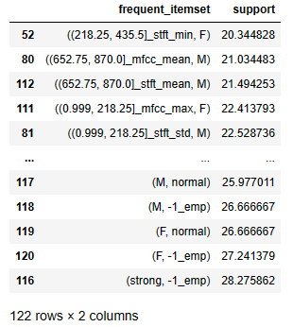

Figure 1: frequent pattern of minimum sizes of 2 with support ascending order.

With a minimum size of 2 the result is 122 itemsets, with the highest support being 28.26%.

Figura 2: frequent pattern of minimum sizes of 3 with support ascending order.

With *zmin = 3*, on the other hand, we obviously obtained fewer results, 64, with the maximum support having dropped to just over 25%.

Figura 3: frequent pattern of minimum sizes of 4 with support ascending order.

With *zmin = 4* we obtained 24 results, it can be seen that the five itemsets with the highest support are the same as those with the highest support obtained with *zmin = 3*, thus maintaining the same maximum value of support.

Despite increasing the minimum size from 2 to 4, i.e. double, we can see that the maximum support value has decreased by just over 3% only. This could be caused by the presence of some attributes such as sample_width, frame_rate and frame_width, which represent standard characteristics for the audio recordings contained in the dataset, so many values are repeated and generate redundant information.